This document provides a step-by-step procedure for migrating the IBM Case Manager V5.3.3 on-premises environment to IBM Business Automation Workflow V20.0.0.2 on containers.

Migrating the IBM Case Manager V5.3.3 interim fix 7 production environment to IBM Business Automation Workflow V20.0.0.2 on containers

Table of Contents

Introduction 2
Prerequisites 2
Migration planning sheet 3
Installing IBM Business Automation Workflow on an OCP environment 5
Updating the custom resource file 5
Post-installation steps 5
Limitations 7

Introduction

This document provides instructions on how to successfully migrate the IBM Case Manager V5.3.3 interim fix 7 on-premises environment to IBM Business Automation Workflow V20.0.0.2 on containers.

The document also discusses migration of multiple target object stores (TOS) with database storage and file storage areas.

The main goal of the migration is to retain the existing databases of the on-premises environment while on-boarding the user environment of IBM Business Automation Workflow on containers.

Prerequisites

You should install IBM Case Manager V5.3.3 interim fix 7 with a production environment deployment. For instructions, see the help topic Configuring the production environment.

Before performing the migration, ensure that the following conditions are met for all the IBM Case Manager V5.3.3 on-premises case solutions that you may want to work with:

- Imported to the design object store (DOS).
- Deployed to the required target area or areas.
- Security manifest applied to all the target areas where the solutions are deployed.

The database configured for the global configuration database (GCD), IBM Content Navigator database, DOS, and TOS should remain intact because the same database will be used after migration. For this reason, ensure that the database is available during the migration. If you are using a file storage object store, ensure that you make a backup for the file storage area.

The Lightweight Directory Access Protocol (LDAP) used in the on-premises environment will also be used for IBM Business Automation Workflow on containers.

Before migration, the administrator should create the docs object store and the application engine object store (AEOS) in the IBM Administration Console for Content Platform Engine (ACCE) on the on-premises environment.

Migration planning sheet

In the Value column of the following table, make a note about the value of each configuration detail. It will help ensure that you don’t omit any configuration details that will be needed for migration.

 | On-premises configuration details | Values
1 | Database server name / IP address
2 | GCD details:  - Database name  - Non-XA data source name  - XA data source name  - Database user name  - Database password
3 | IBM Content Navigator database details:  - Database name  - Non-XA data source name  - XA data source name  - Database user name  - Database password  - IBM Content Navigator schema name  - IBM Content Navigator table space name
4 | DOS database details:  - Database name  - Non-XA data source name  - XA data source name  - Database user name  - Database password
5 | TOS database details:  - Database name  - Non-XA data source name  - XA data source name  - Database user name  - Database password
6 | If a file storage TOS is used:  - Database name  - Non-XA data source name  - XA data source name  - Database user name  - Database password  - Backup of the file storage area files
7 | LDAP configuration details for on-premises environment
8 | Administrator user
9 | Administrator group
10 | Connection point names (for target object stores only)
11 | IBM Case Manager custom plugin file and file name
12 | FileNet P8 domain name
13 | Docs object store database details:  - Database name  - Non-XA data source name  - XA data source name  - Database user name  - Database password
14 | AEOS database details:  - Database name  - Non-XA data source name  - XA data source name  - Database user name  - Database password

Installing IBM Business Automation Workflow on an OCP environment

For information on installing IBM Business Automation Workflow on an OpenShift Container Platform (OCP) environment, see the help topic Installation options.

Updating the custom resource file

For information on updating the custom resource file, see the embedded comments in the custom resource file (which is contained in the attached ZIP file).

Post installation steps

Regular installation with a single TOS:
In a single TOS with database storage, the environment is ready to use immediately.

Installation with a file storage TOS:
If a file storage object store is used, log into the ACCE. After logging in, update the path of the file storage device to point to the location in the Content Platform Engine physical volume (PV) where the file storage backup is copied to (as shown in the following screen capture).

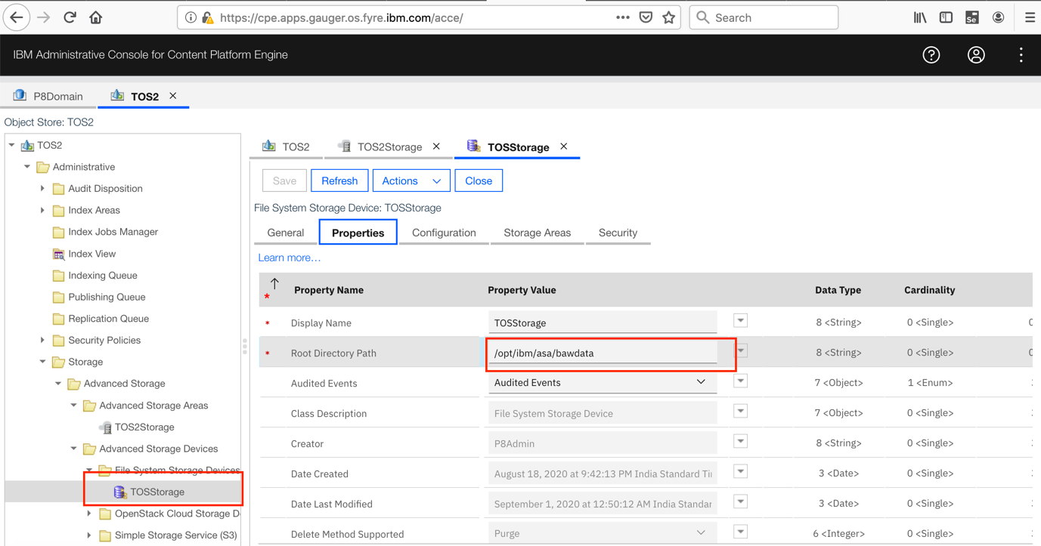

Mandatory steps for more than one TOS:
If there are any file storage target areas, update the path as shown in the screen capture above and then run the case init job as described below.

In a multiple TOS environment, the case init job must be run for all the target areas as described in the following steps:

- Run the following command to export the case initjob.json file:
oc get job demo-instance1-baw-case-init-job -o
json > initJob.json

- Edit the initJob.json file.
- Remove any lines that contain a "controller-uid" string.
- Update or add the following environment variables in env: array:
{
"name": "TOS_OBJECTSTORE_NAME",
"value": "<TOS_name>"
},
{
"name": "CONN_POINT_NAME",
"value": "<connection_point_name>"
},
{
"name": "TARGET_ENV_NAME",
"value": "<target_environment_name>"
},
- Save your updates.
- Delete the config.ok file from the following directory:
/nfsdata/icn/pluginstore/properties
- Run the following command:
oc replace --force -f initJob.json

Working with custom plugins and custom extensions after migration
If you have a production environment with custom plugins and custom extensions, the plugins should be copied to the following directory:

/nfsdata/icn/pluginstore

In the custom resource file, add the following lines under the “Case configurations” section and then deploy the custom resource file:

custom_package_names: "ICMCustomWidgets.zip"
custom_extension_names: "CustomEditors.zip"

For more information about custom packages and custom extensions, see the help topic Configuring custom case extensions for a container environment.

Enabling certificate authority (CA) and case history stores after migration
Enable the CA and case history stores in the ACCE (as shown in the following screen capture) and then restart the Content Platform Engine pod for the changes to take effect.

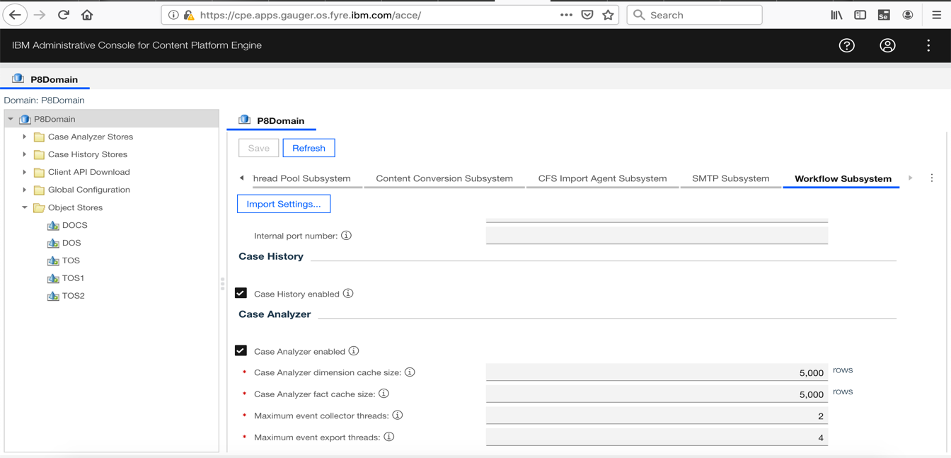

Configure emitters after migration:
For information about configuring the emitters after migration, see the help topic IBM Business Automation Workflow and Workstream Services parameters.

Limitations and restrictions

- Case forms are not supported in container environments. As a result, solutions with forms will not work as expected and a message will be displayed to inform you that forms are not supported on a containers environment.
- Your case solutions should be deployed and the audit or security manifest should be applied to the required target areas before migration. After migration, the on-premises solutions cannot be redeployed and the audit or security manifest cannot be modified.
- After migration, the migrated object stores should not be used from the on-premises environment. The IBM Content Navigator URL for the on-premises environment will no longer work.

